Ideation phase Brainstorm and Idea Prioritization Template
Date | 1.10.2025
Team ID | NM2025TMID01384
Project Name | Calculating family expenses
Maximum Marks | 4 marks

Brainstorm and Idea Prioritization :
The project “Calculating Family Expenses in ServiceNow” aims to simplify household budgeting by using ServiceNow’s automation and reporting capabilities. Ideas include creating a custom expense form for adding and categorizing daily costs, setting monthly budgets with alerts for overspending, and generating visual dashboards to track trends and savings. Additional features like role-based access for family members, automated categorization, and notifications can enhance usability, while future integrations with bank APIs could automate data entry. The focus is on developing a user-friendly, centralized, and data-driven solution to manage family finances efficiently.
Step 1:Team Gathering ,Collaboration:
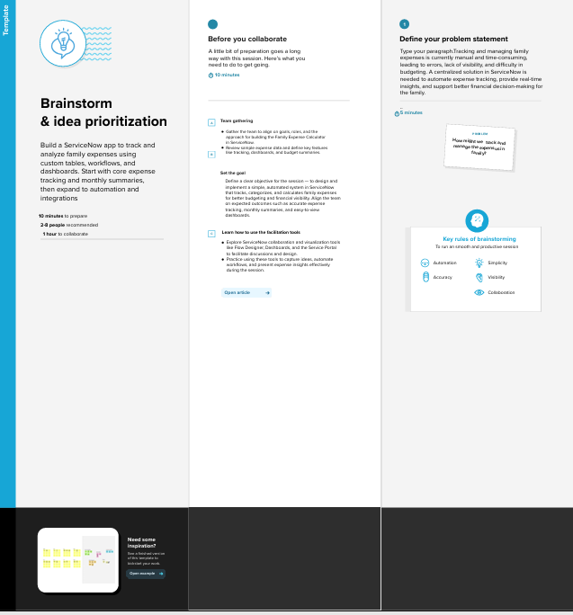

Step 2: Brainstorm,Idea Listing and Grouping
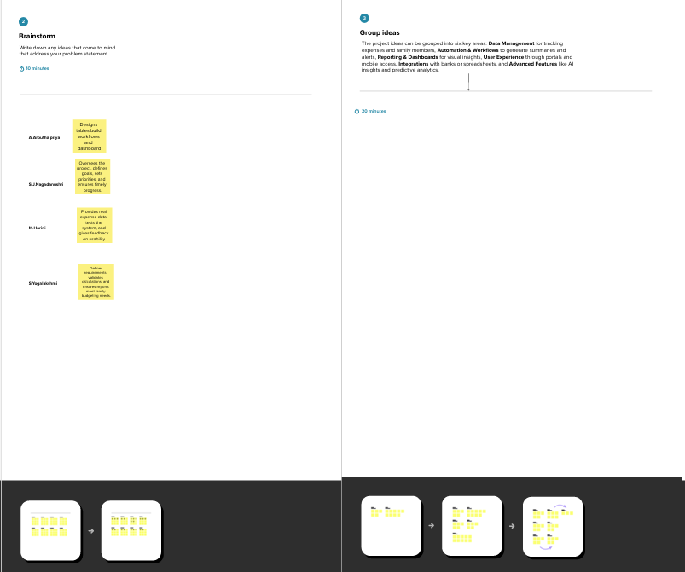

Step3:Idea prioritization

